Booking Guide for Graduation
Student login
Go to: https://www2.edeandravenscroft.com/graduation/

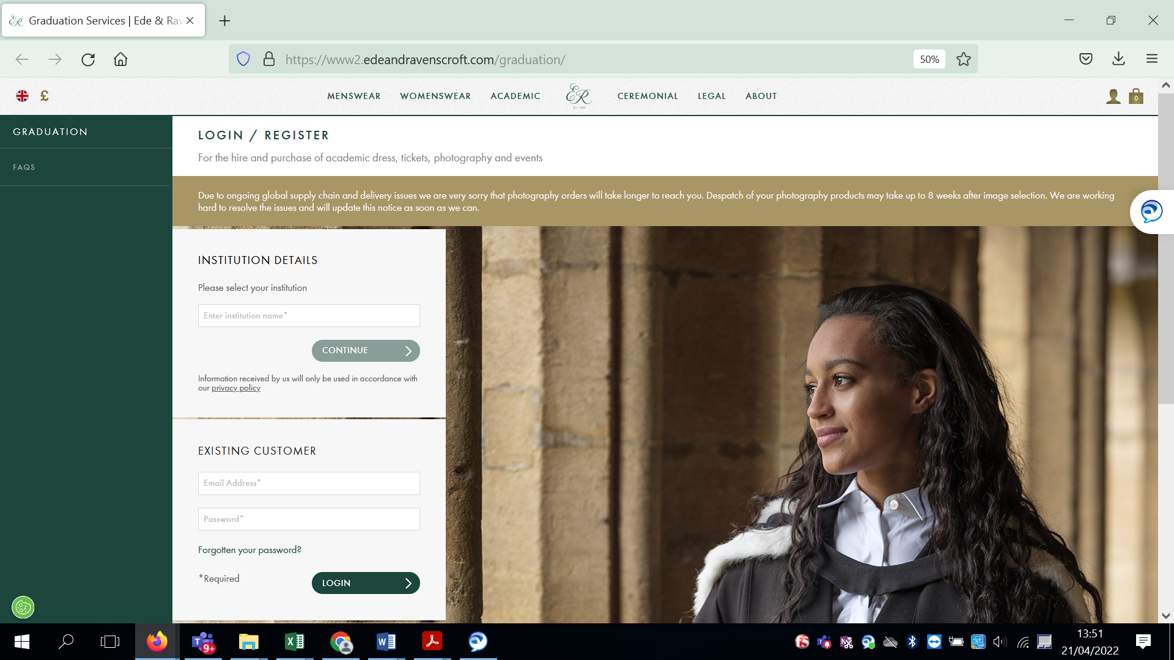

If this is the first time you are graduating from Middlesex then you should search for the institution.

If you have attended a Middlesex graduation ceremony before then you should be an existing customer.

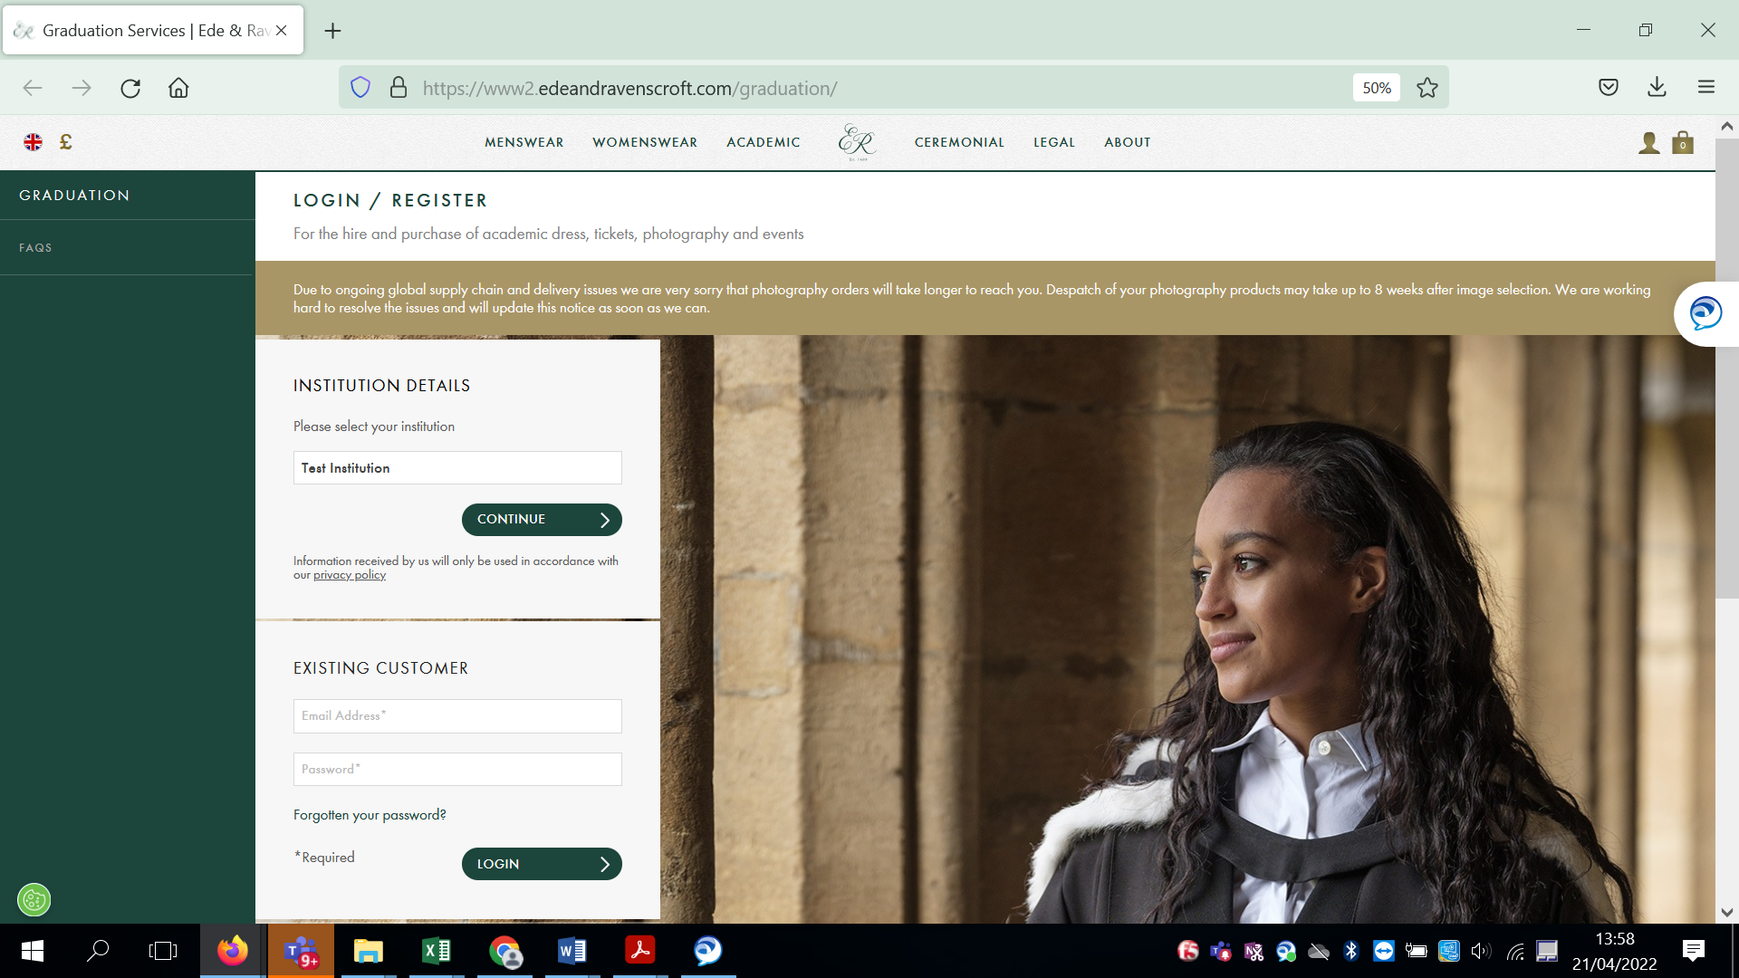

Type in Middlesex (do not use Test Institution – this is just an example) and click continue.

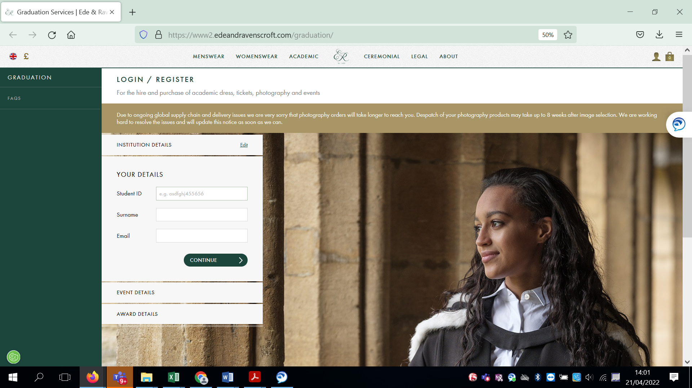

Enter your student id number, surname and the email address you would like to use for your booking. This can be any email, it does not have to be your MDX email address and then click continue.

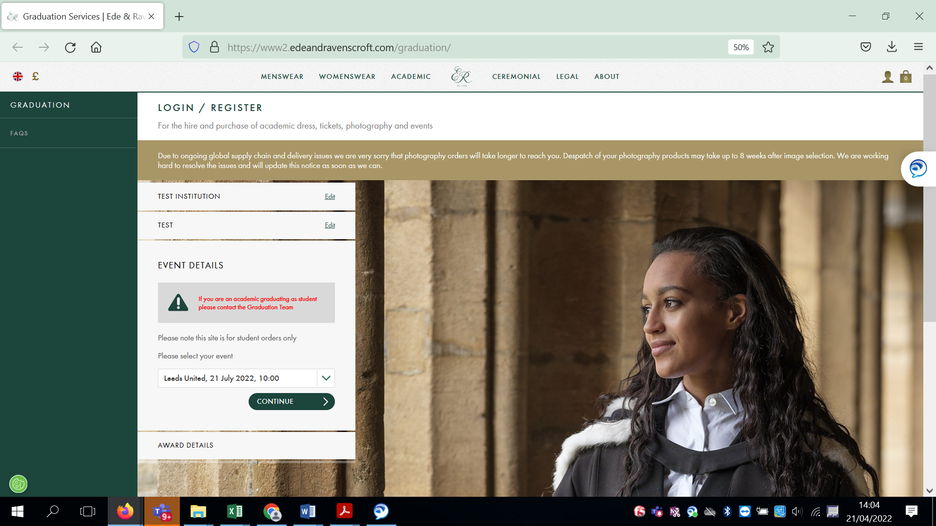

A dropdown box will appear with the ceremony date and time you have been allocated to, this cannot be amended. Click continue.

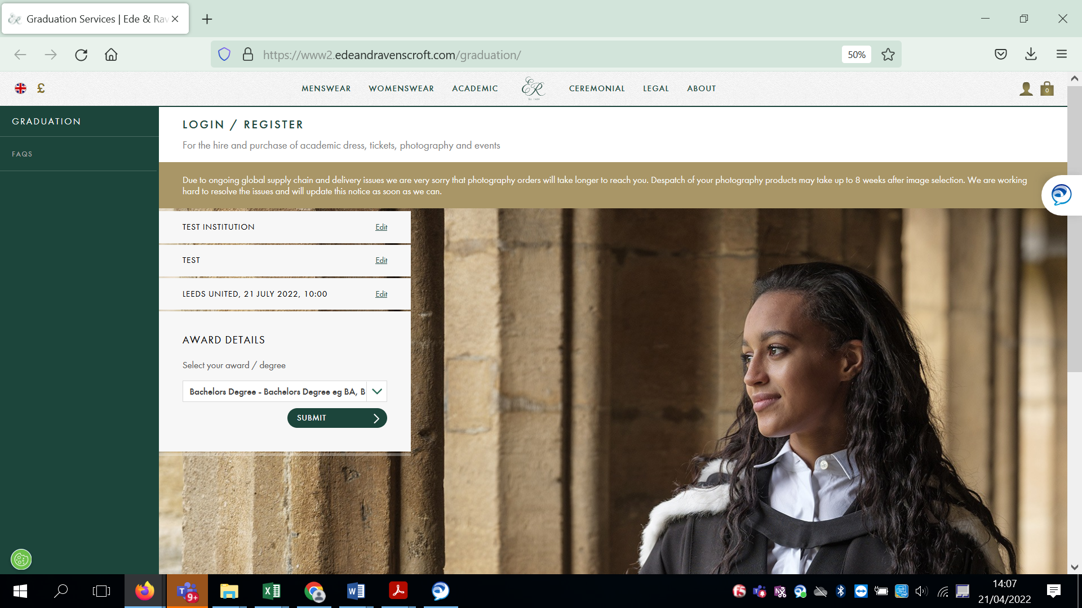

Your award is pre-populated. This relates to the gown you will be wearing. (For those on a Bachelors degree 1st degree does not relate to your classification). If you need to amend this, or think it is incorrect please contact the graduation office on 0208 411 6770 or graduation@mdx.ac.uk Click submit.

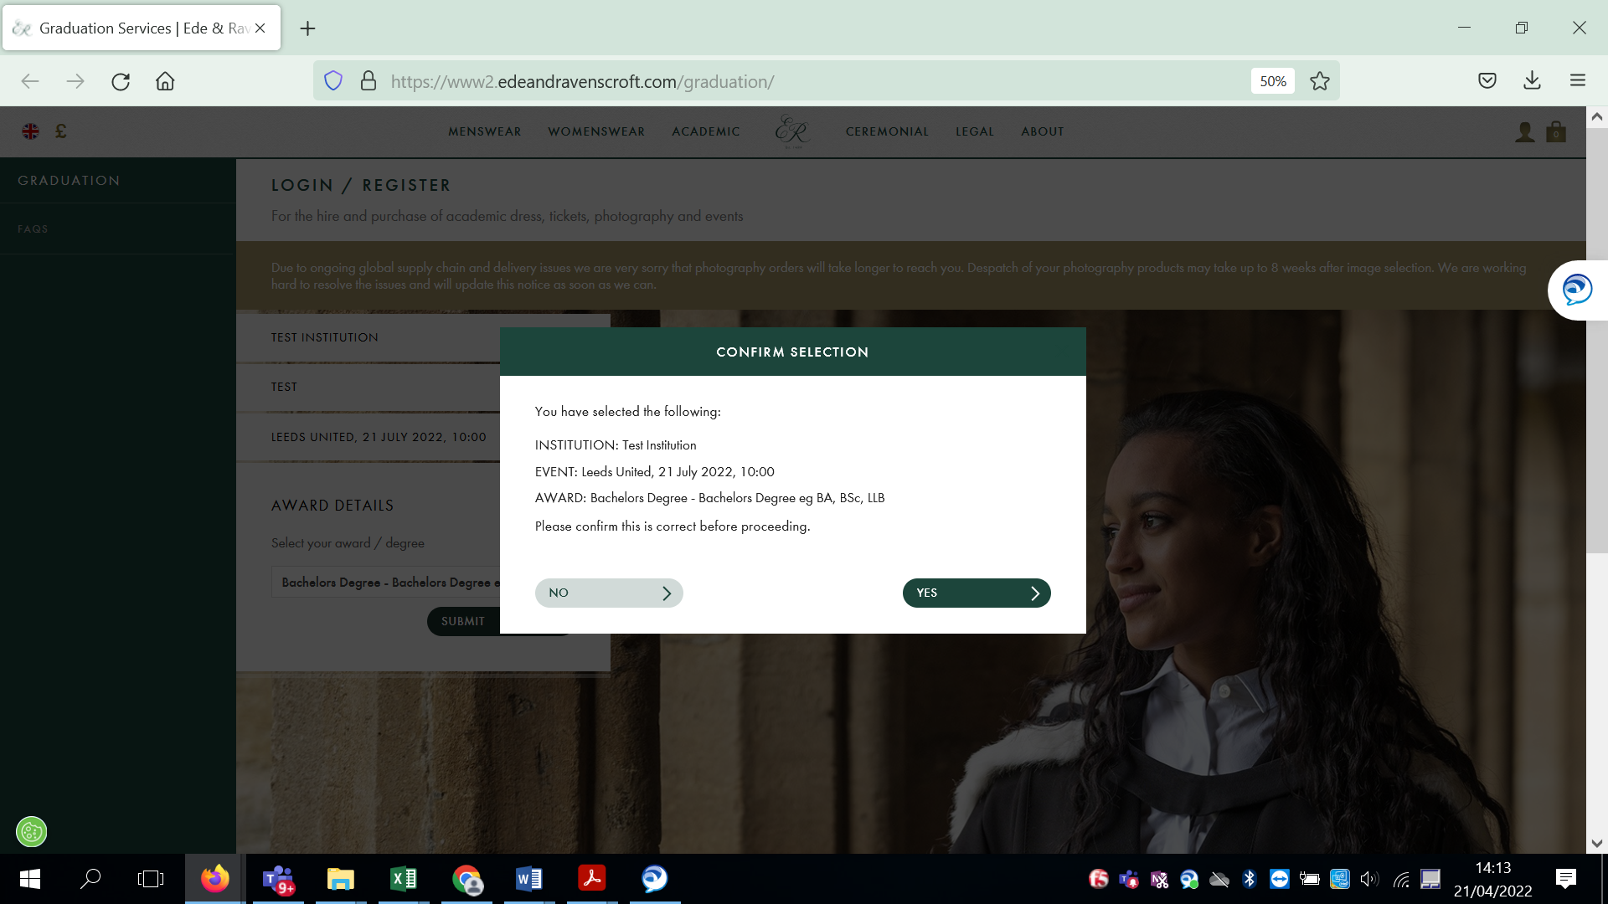

Please check the ceremony and degree and let us know of anything that you think is incorrect.
If everything is correct click Yes.

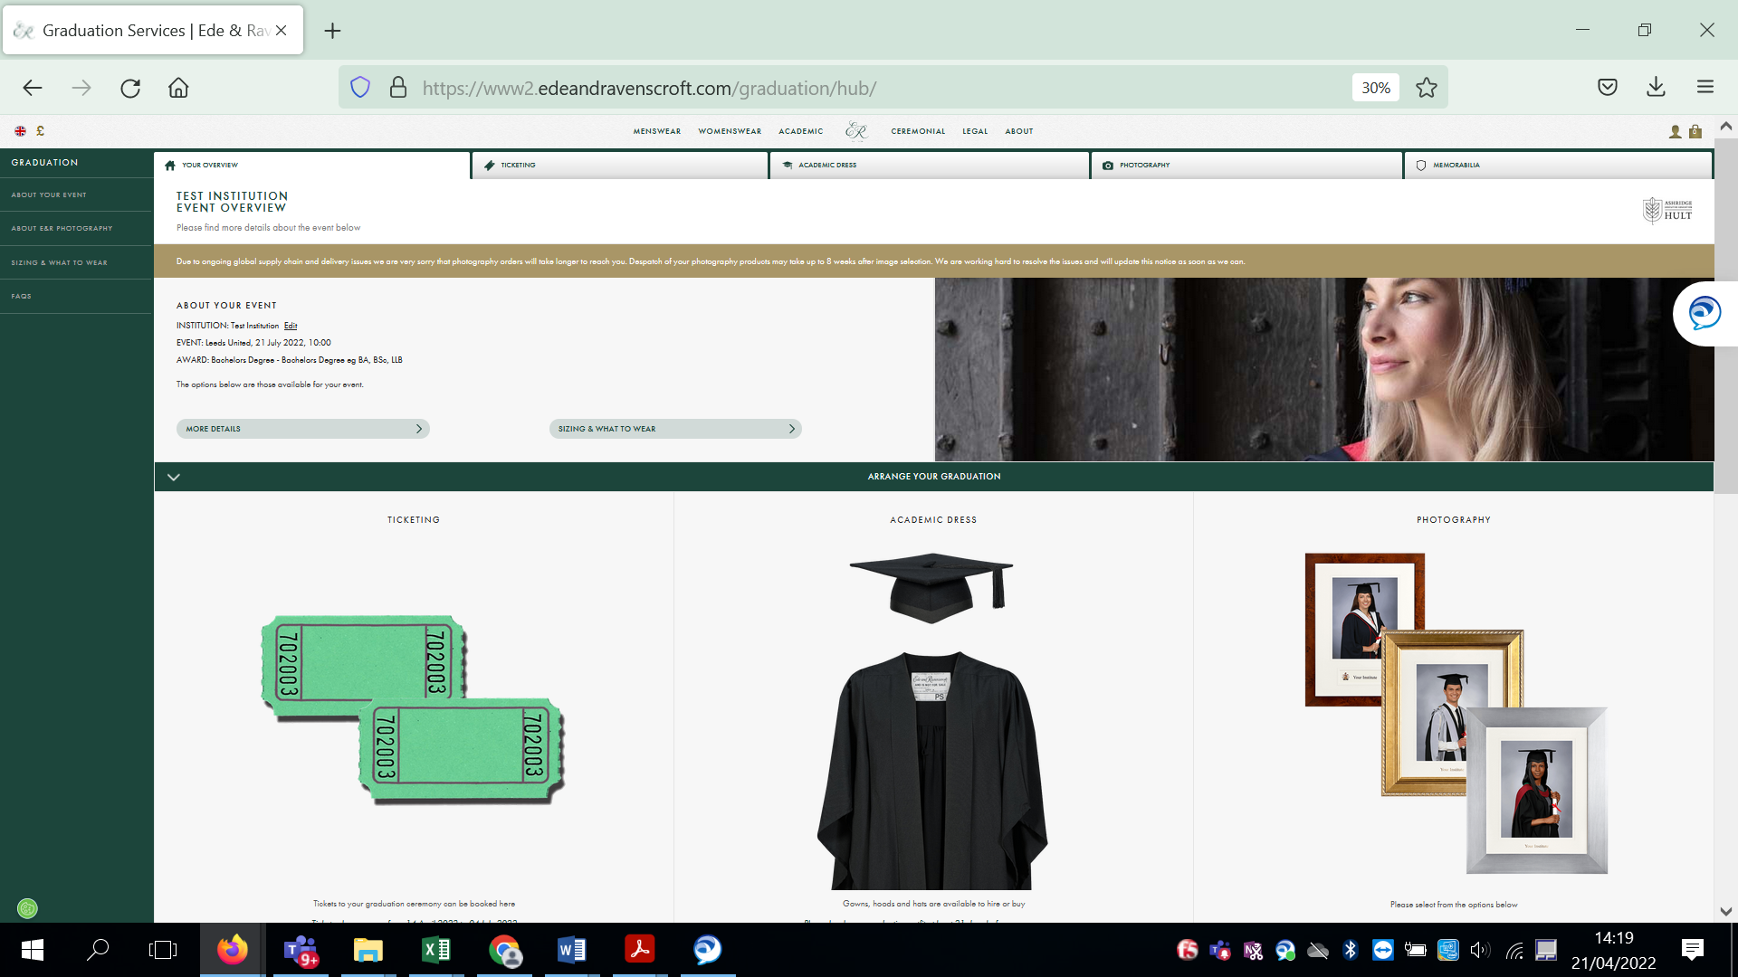

This is your homepage – from here you book your ticket to attend your ceremony, book guest tickets, gowns and photography.

Student and Guest Tickets
The first thing to do is to book your own ticket – you must do this so we know you would like to attend, and a seat is allocated to you. You can either click on the TICKETING tab at the top of the page, or the picture of the tickets.

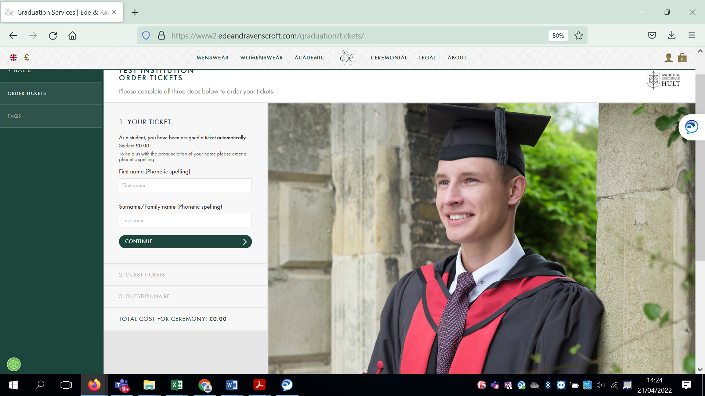

Enter a phonetic spelling of your name. For example

Alphabet would be al-fuh-bet
Easy would be ee-zee

Then click Continue.

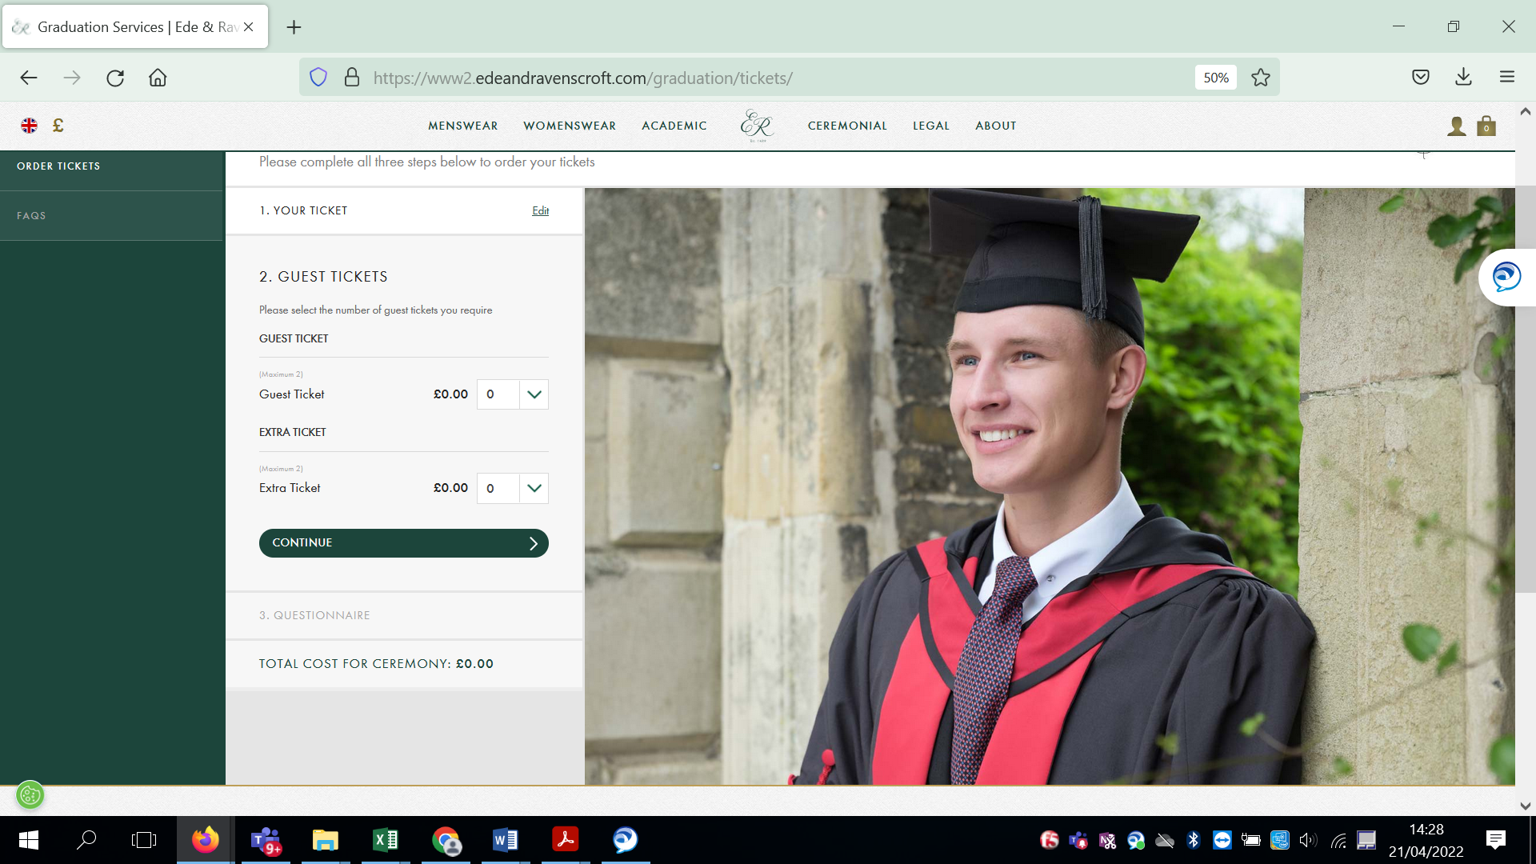

Enter the number of guest tickets that you would like (up to a maximum of two). As this is an example page you will see details for extra tickets however this part will not be live until extra tickets go on sale and further instructions will be available then. Click continue.

If you do not require any guest tickets then just Click Continue.

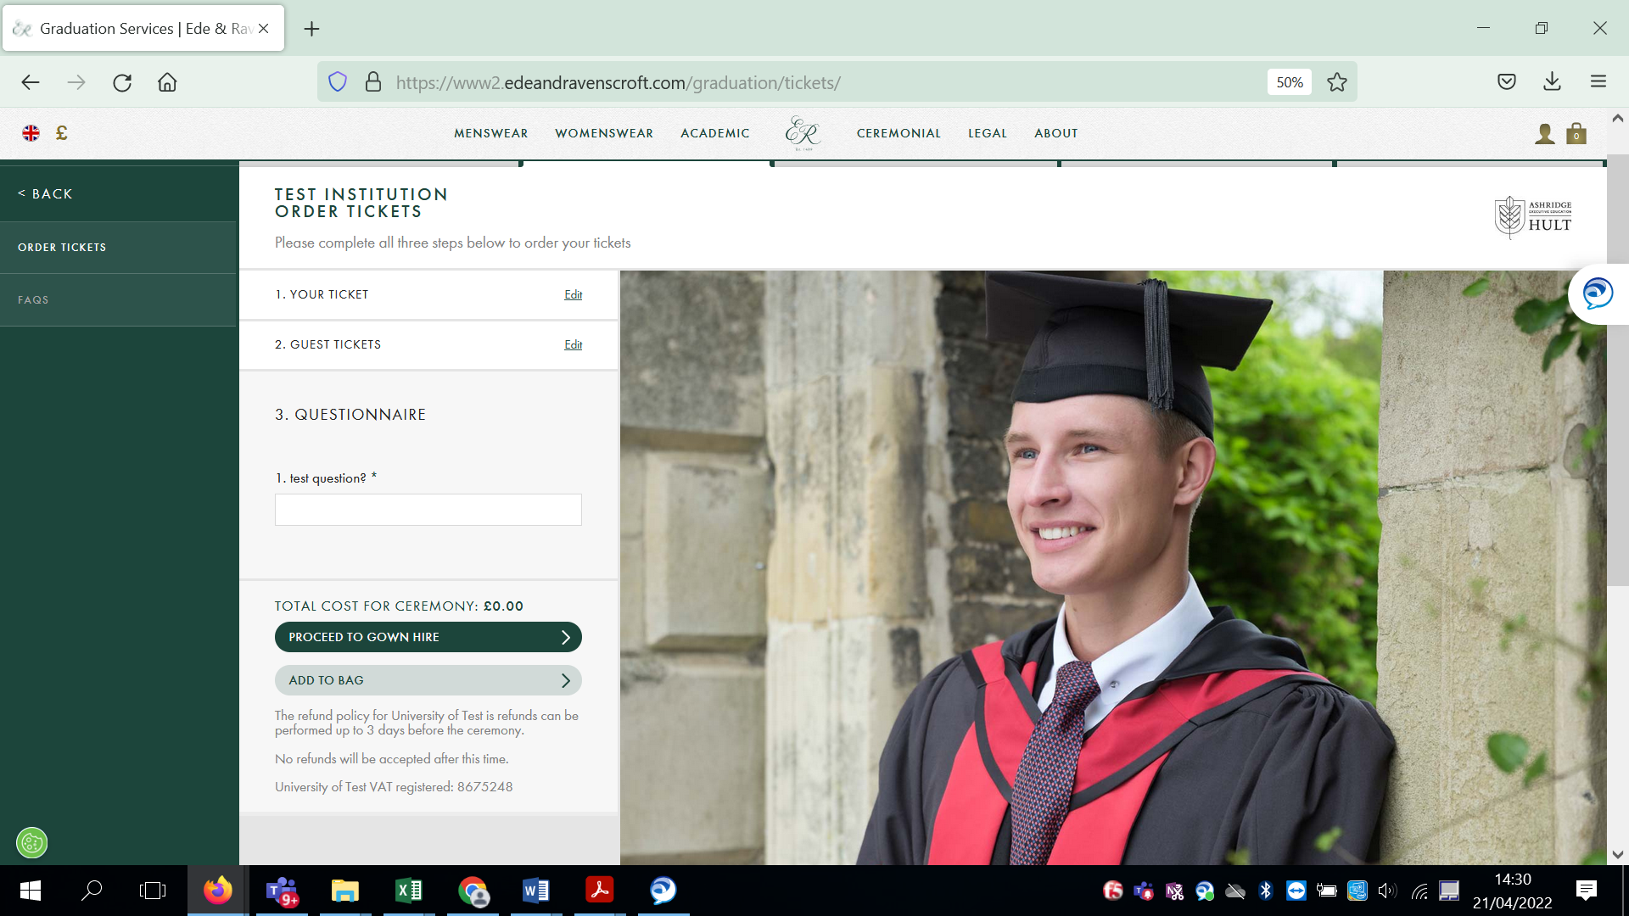

If we have any questions that we would like to ask you these will be included in the questionnaire section. Click on proceed to gown hire.
Gown Hire

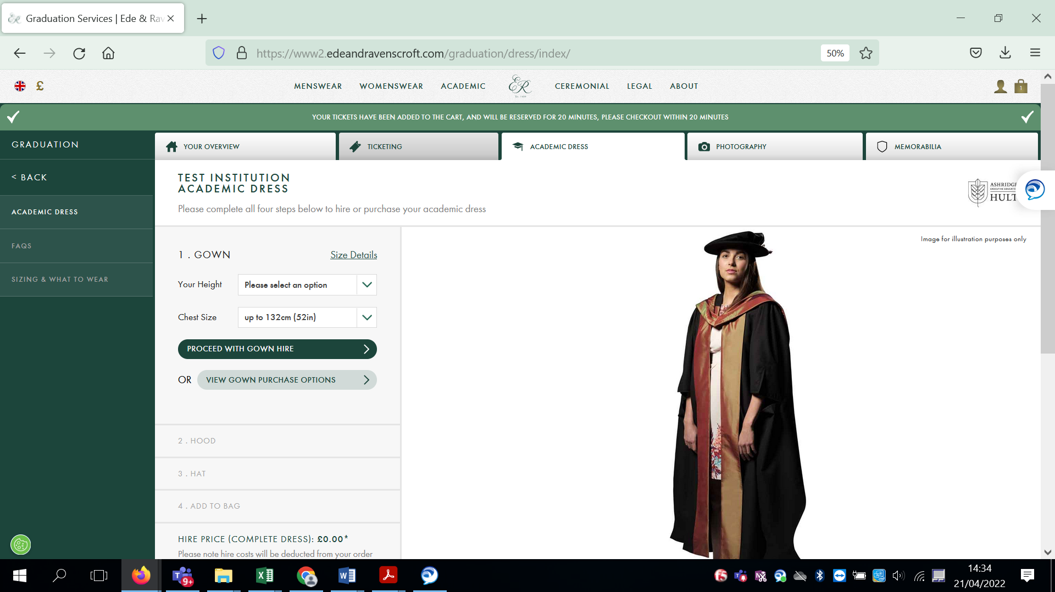

If you are already in the process of purchasing tickets you will automatically be taken on the gownhire part of the site. You can also access this by clicking on the Gownhire tab or the picture of the gown in your homepage.

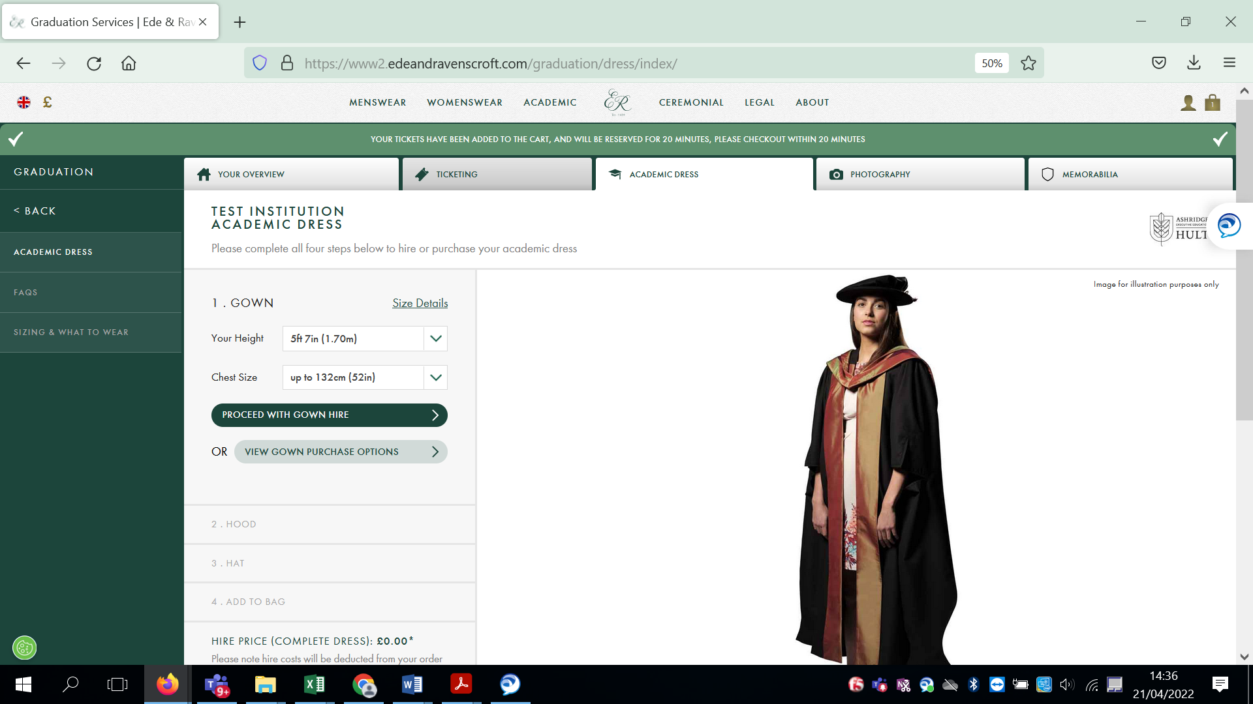
Enter your height and chest size and then click on Proceed with Gown Hire. Only click View Gown Purchase Options if you wish to buy a gown for your own personal use.

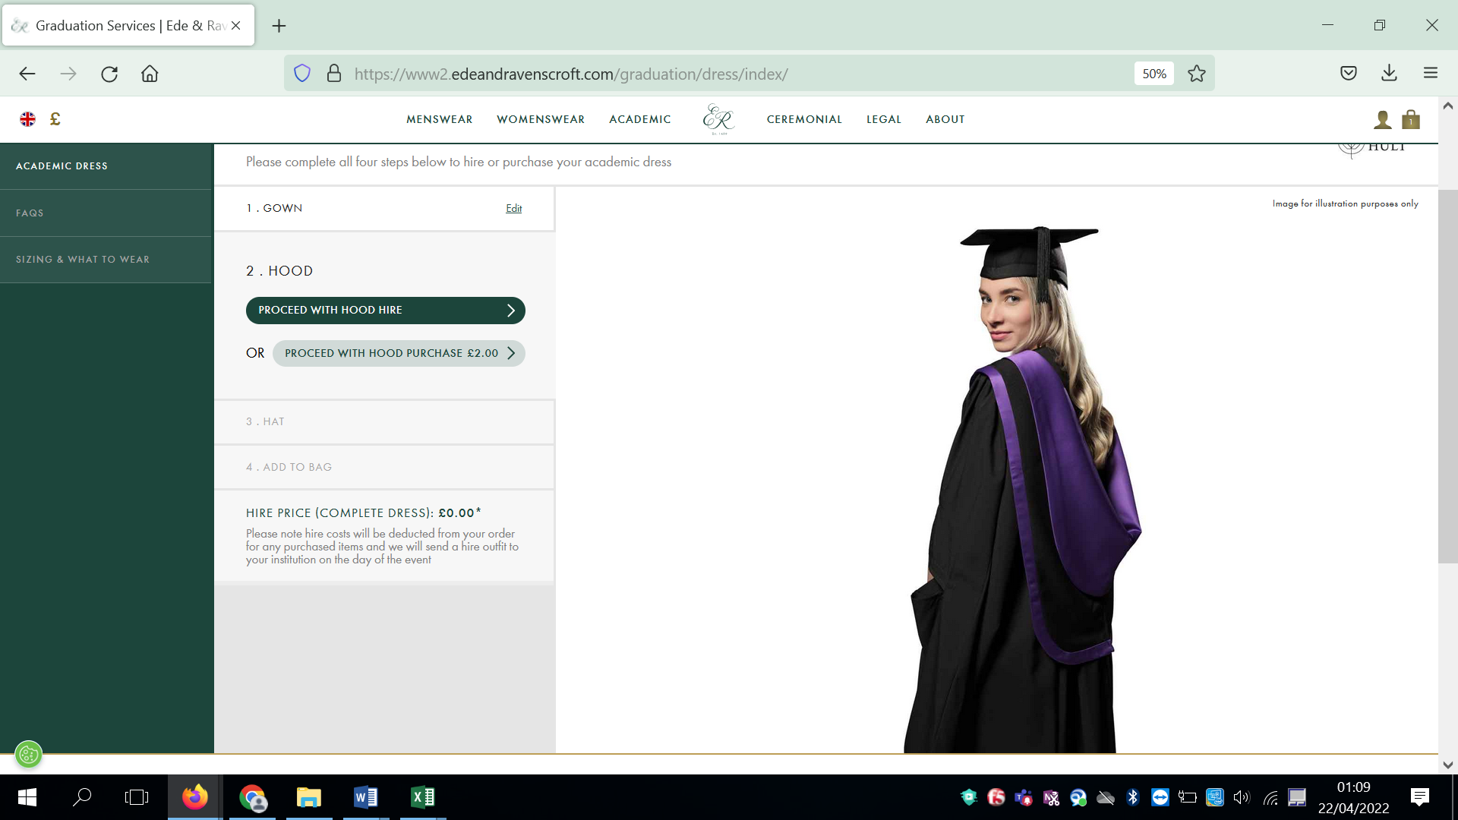

Click on proceed with hood hire

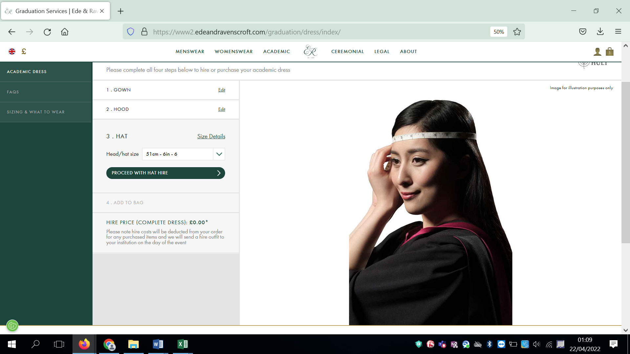

Measure your head for your hat size. If you click on the Size Details this will give you help with sizing for your gown and hat.
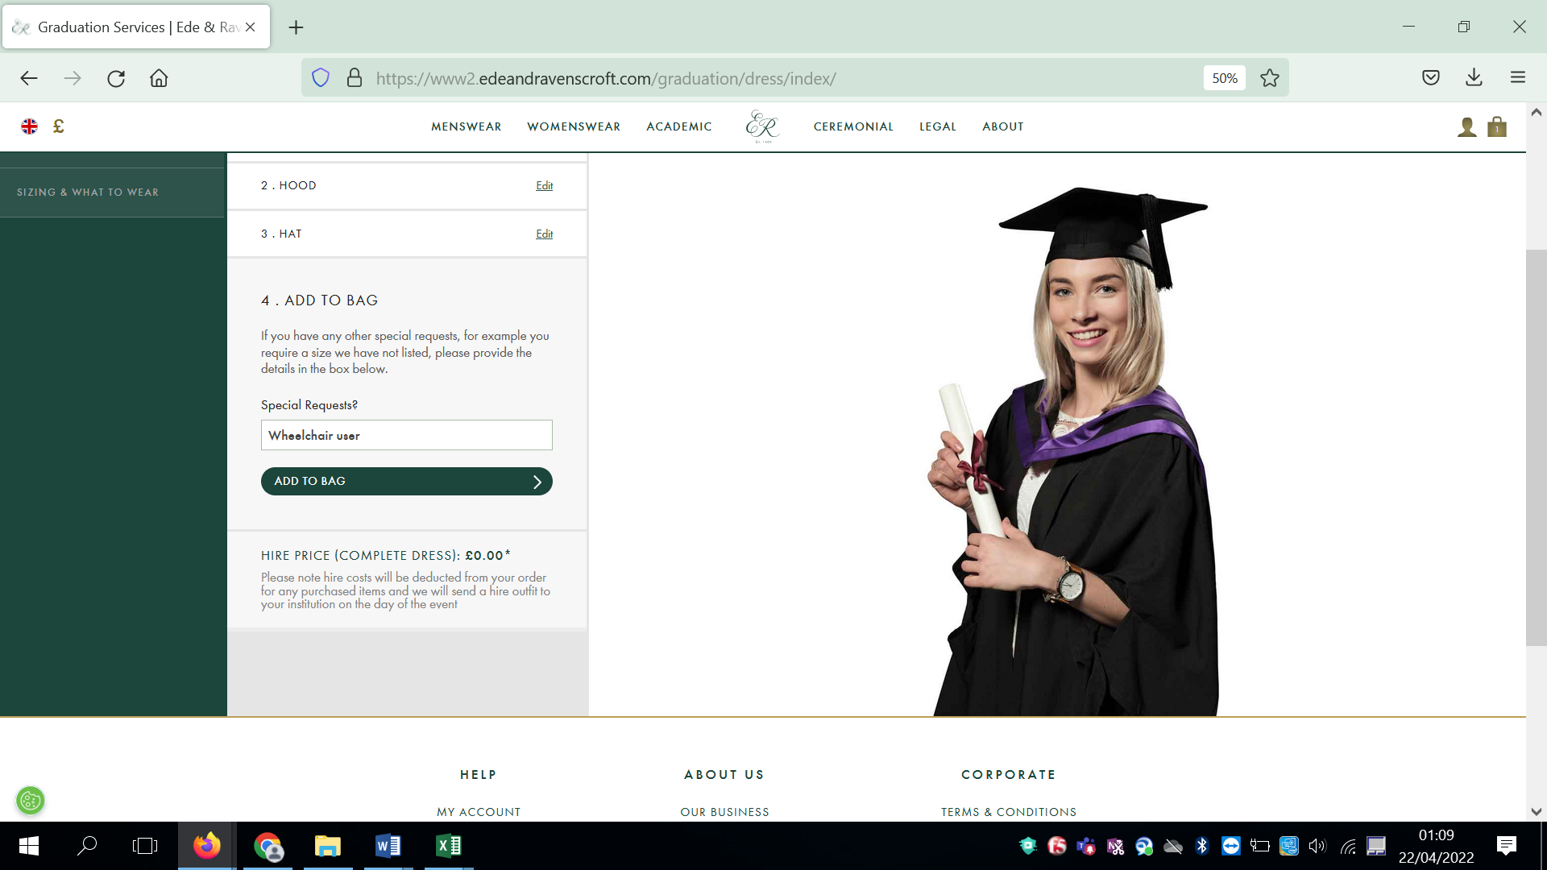

If you have any special gown requests such as being a wheelchair user, are under 4ft 8in or over 6ft 6in please enter those details into the box. Please do not write n/a, no etc. Only populate this section if you actually had a request.

The picture of the gown you see is just an example, it is not the actual gown colours you will be wearing.

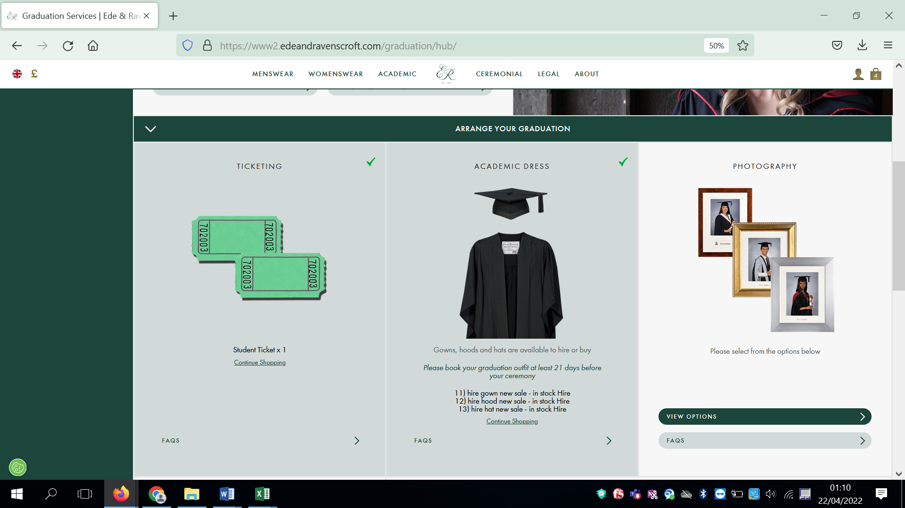

The parts of the process that you have competed will turn light green and be ticked.

Photography and Frames

Click on the photography picture

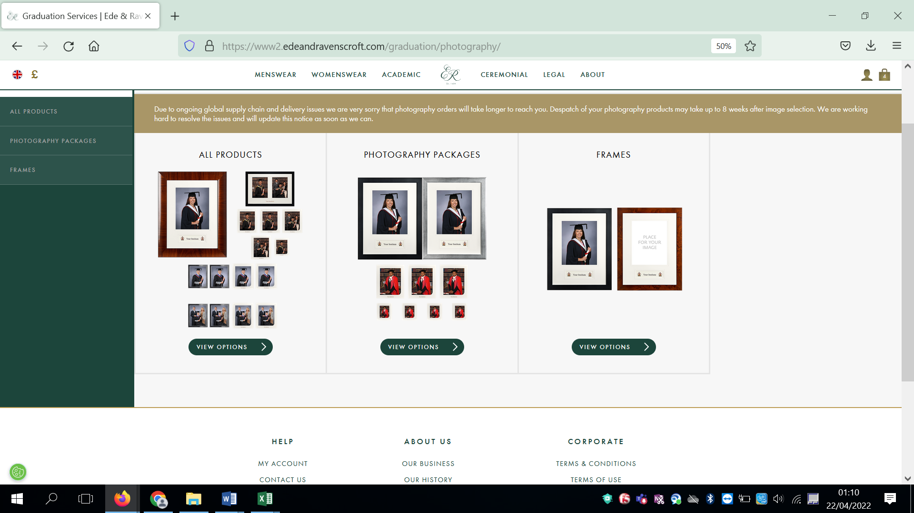

The photography products are split into All Products, Photography Packages and Frames. Choose the section you would like to look at.

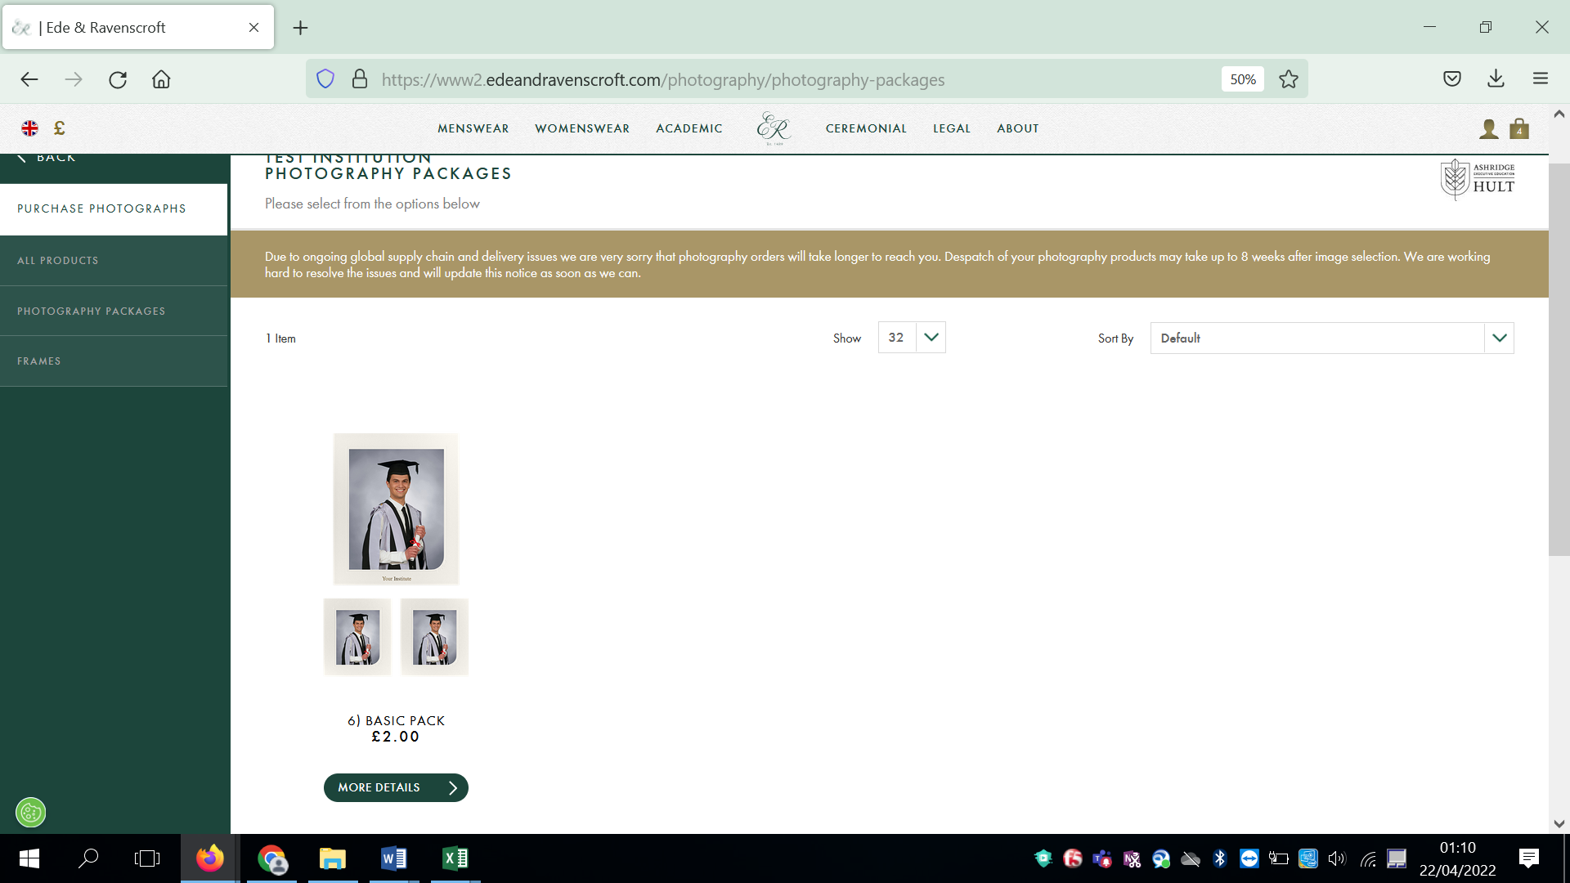

Click on the image or the More Details tab for further information about the product.
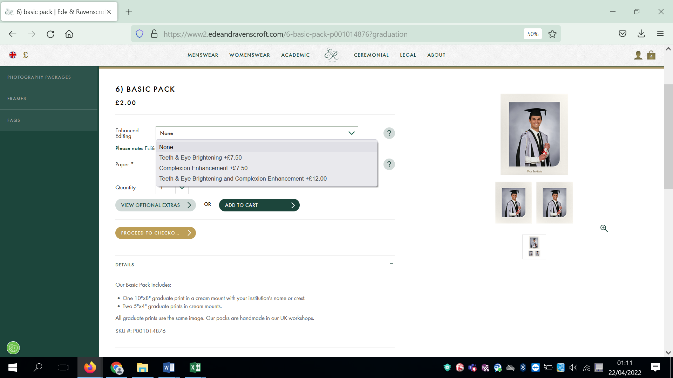

You can then choose if you would like your photos edited and the type of paper they are printed on.

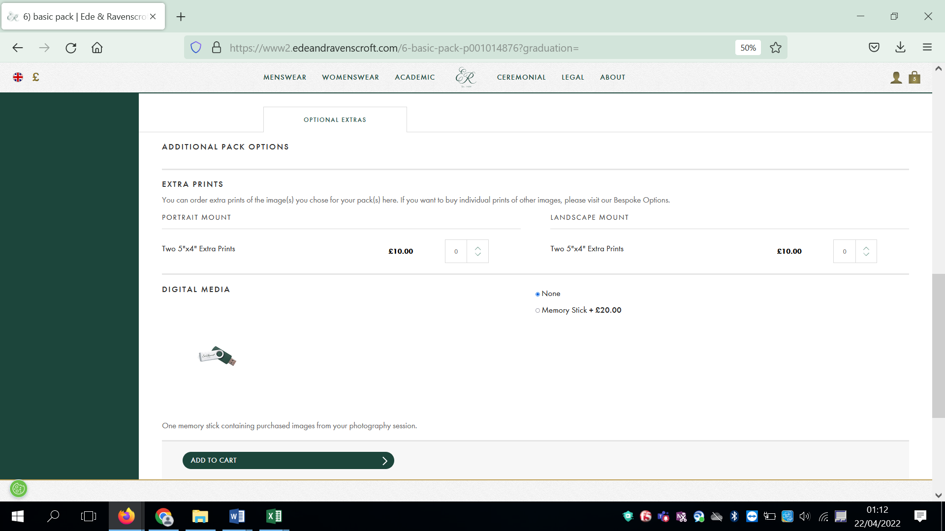

Scroll further down the page and any optional extras such as extra prints and USB sticks are shown.

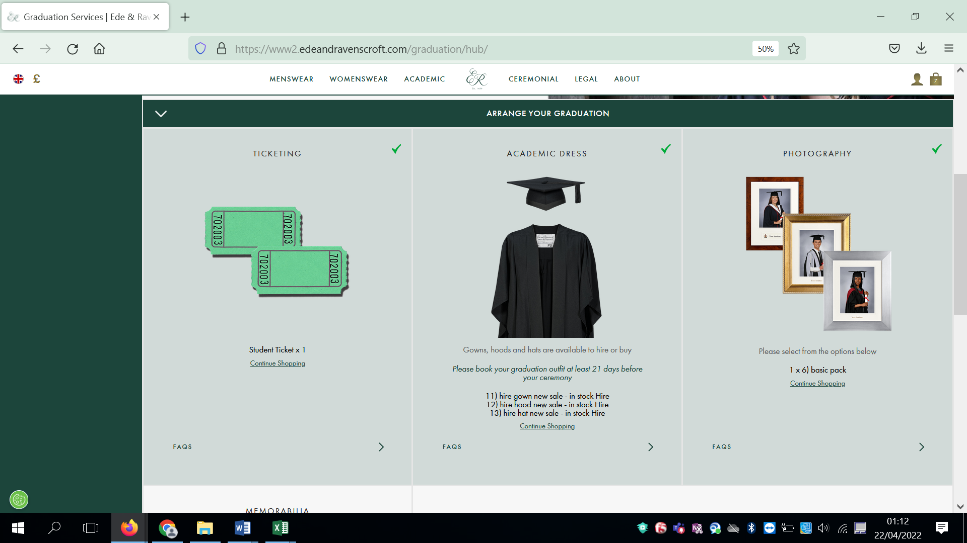

Once you have completed all three processes they will be light green and ticked.

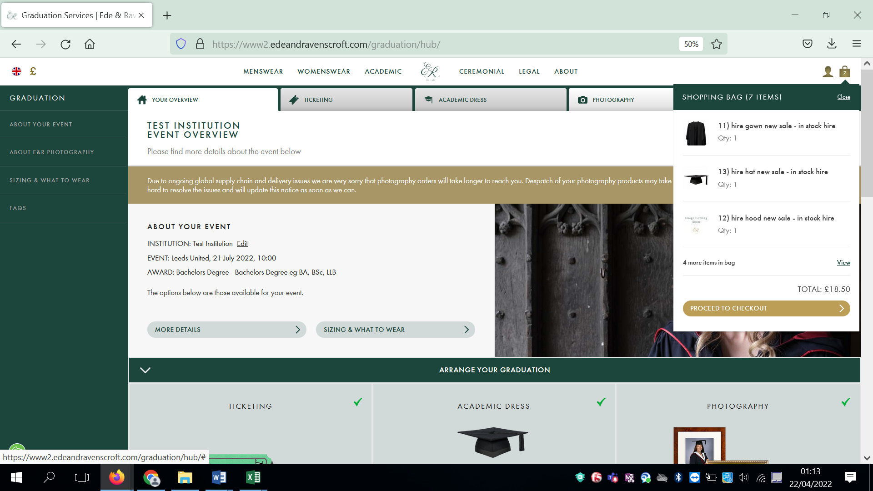

In the top right-hand corner click on the bag to show all of your items and then click Proceed to Checkout.
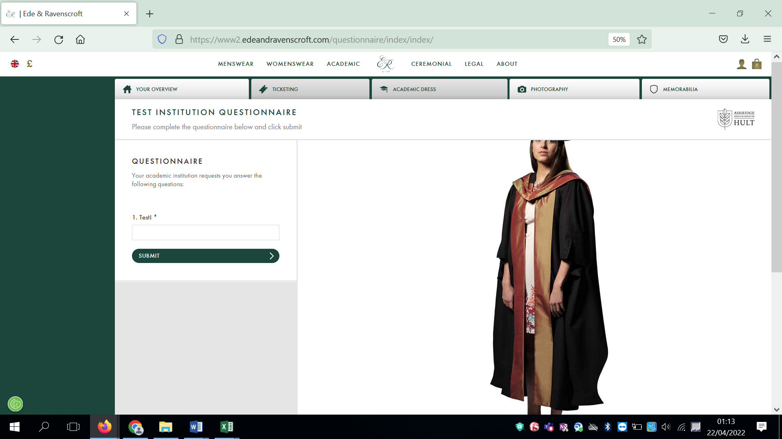

At this point there may be mandatory questions to answer. If you answer YES we will contact you for further details if needed.

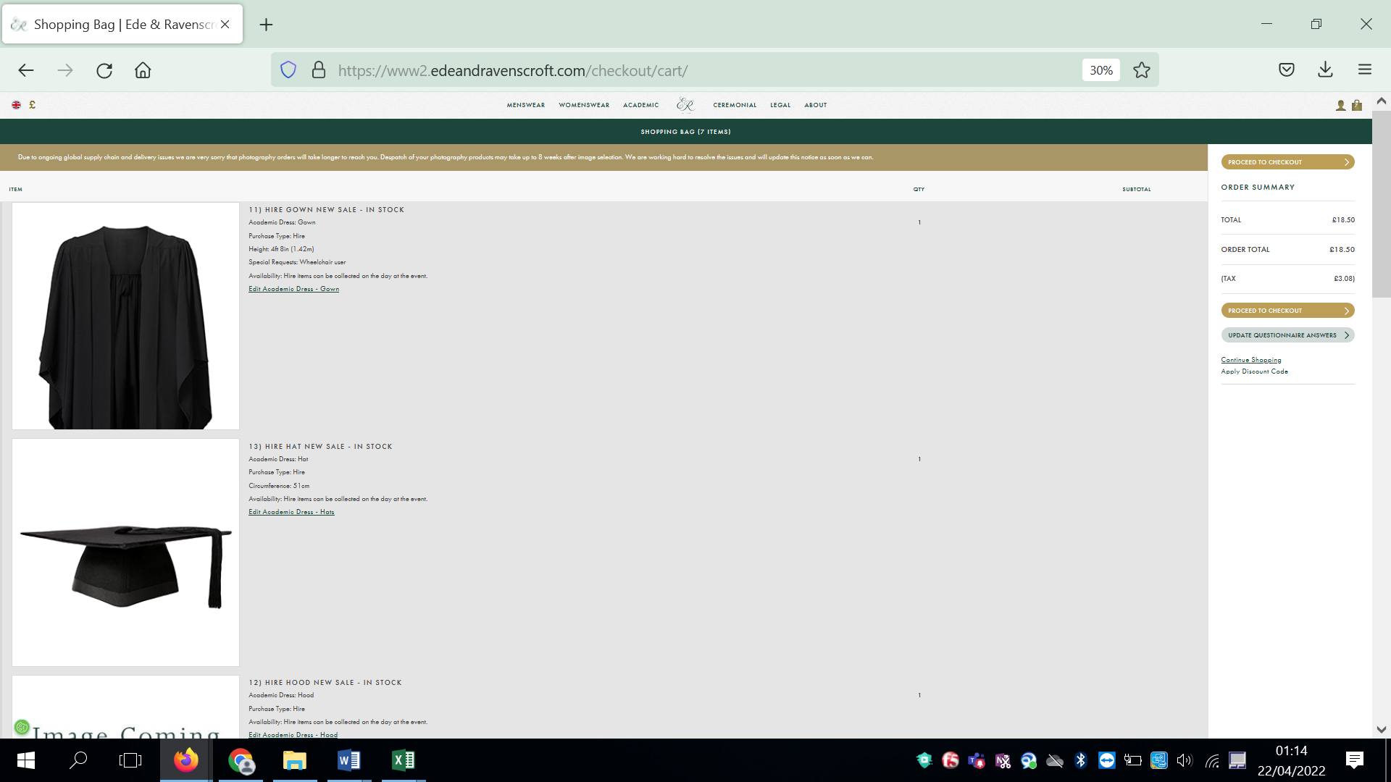

View the contents of your bag and if you are happy click on Proceed to Checkout.
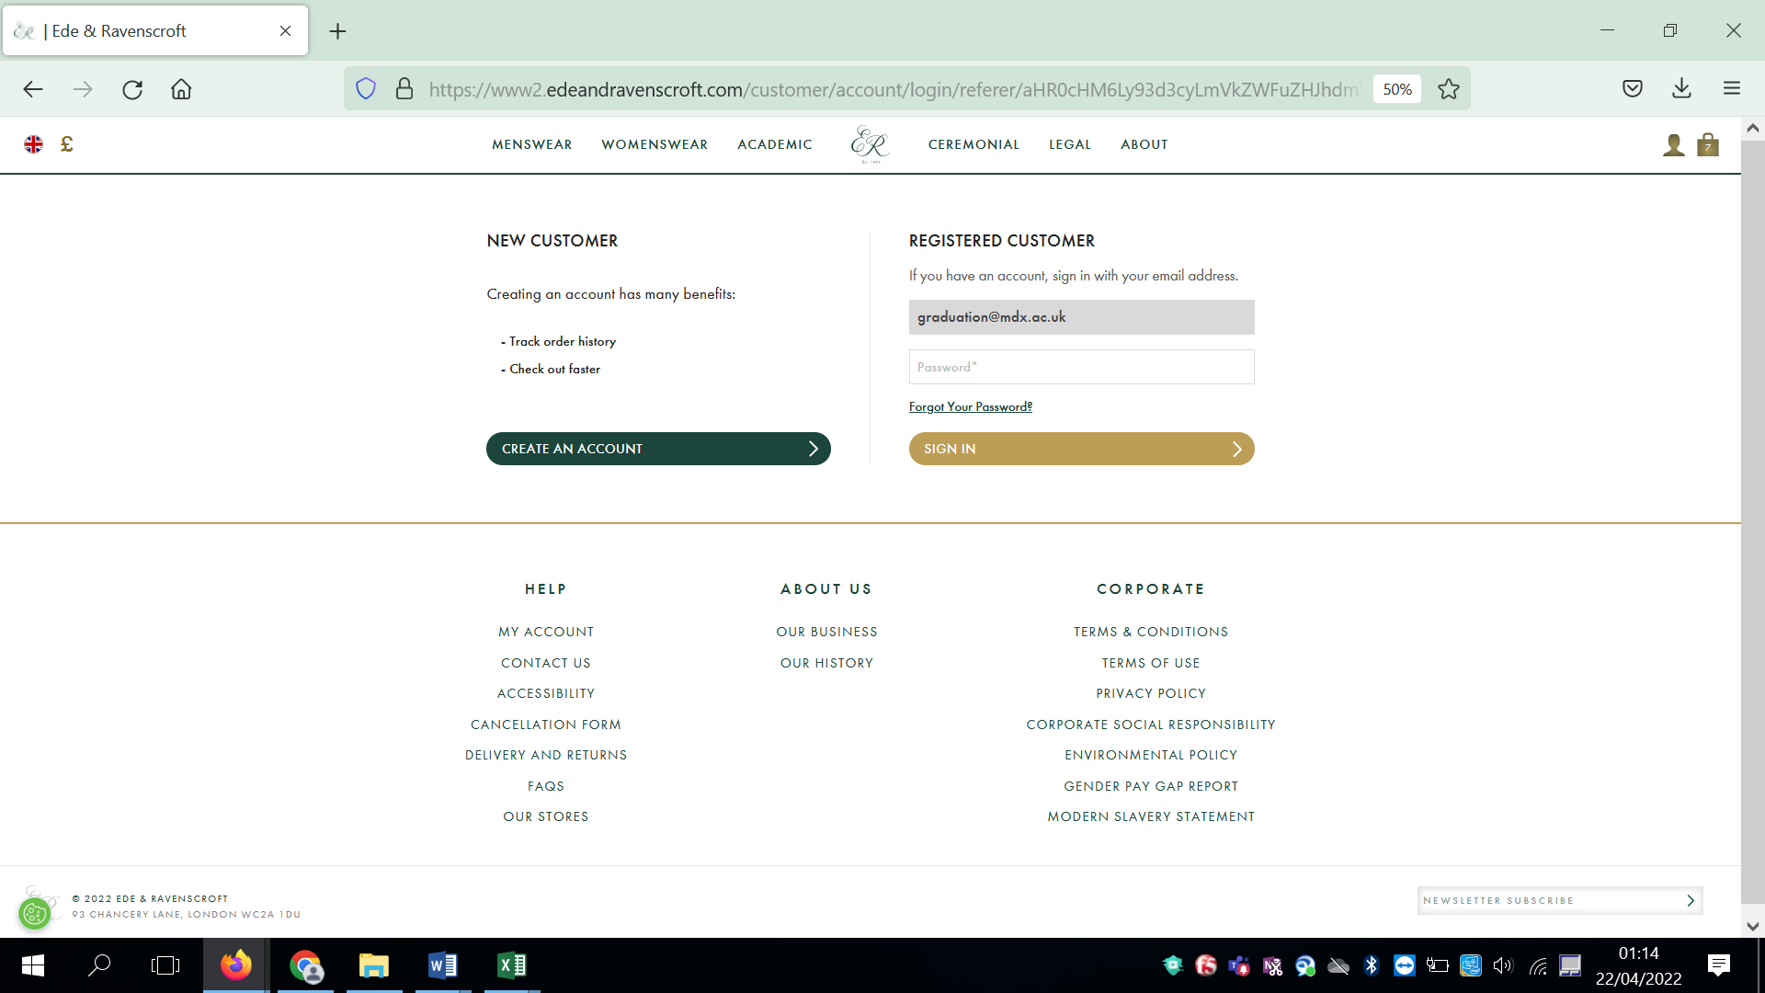

You will then need to create an account if you have never used the website before. If you have attended a Middlesex graduation in the past, then you should already have an account.

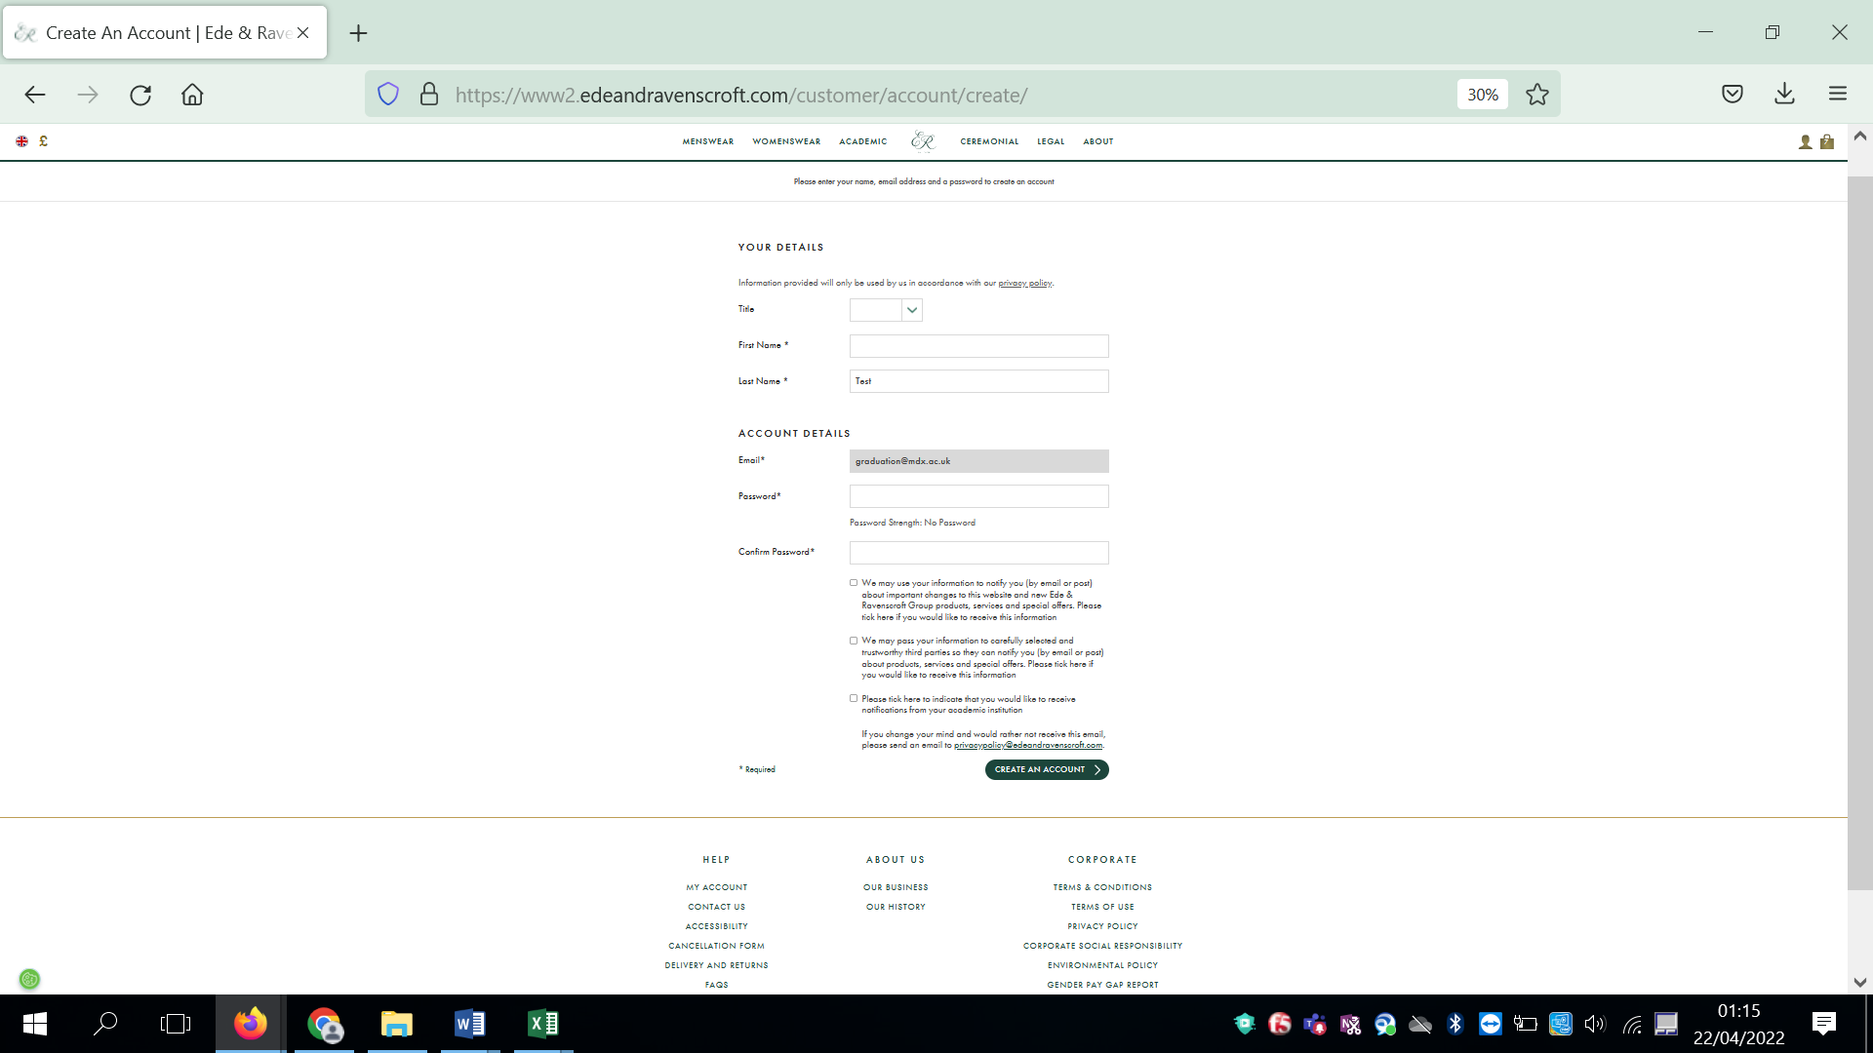

Complete your details and click on Create an Account.

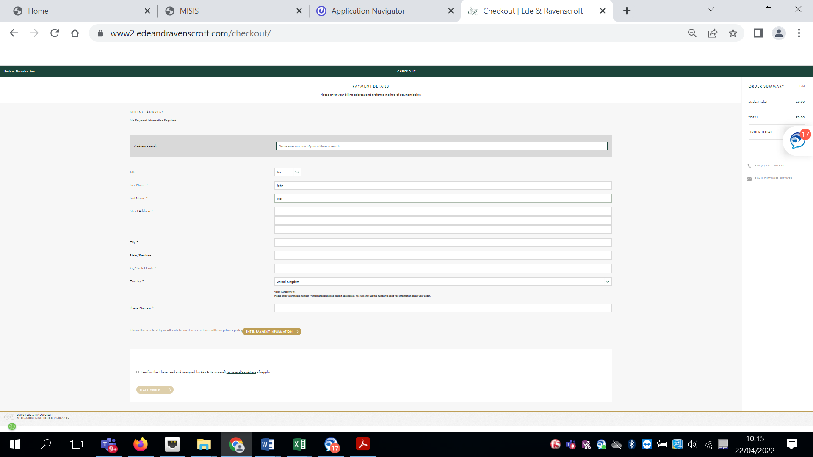

Complete your billing address details and make sure you click to accept that you have read the Terms and Conditions at Terms and Conditions | UniHub (mdx.ac.uk). Then click on Enter Payment Information.

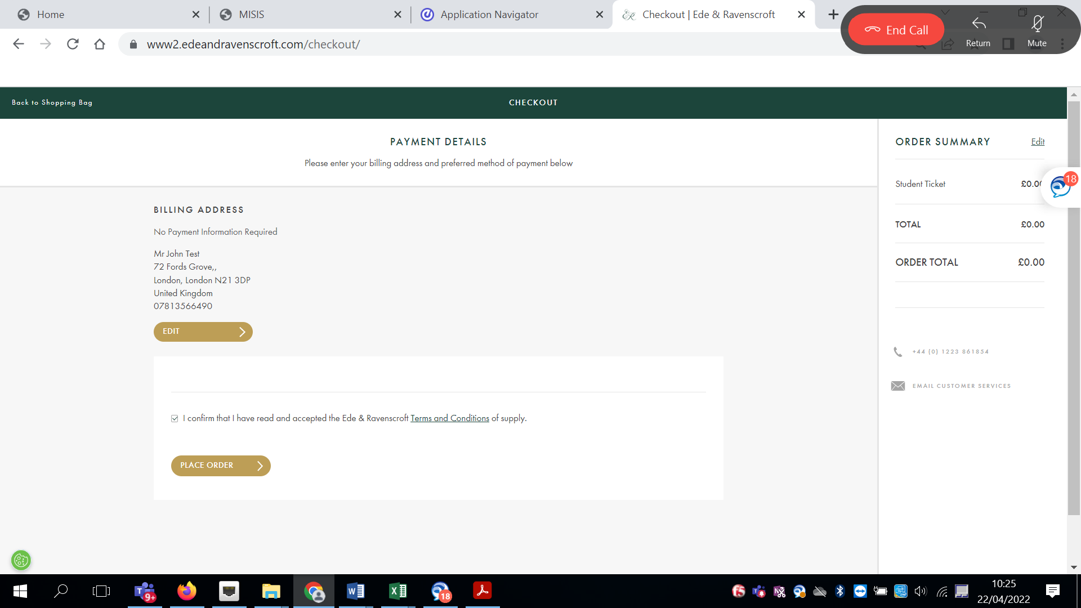

If you need to make a payment you should enter your payment details on this screen. Then click Place Order.

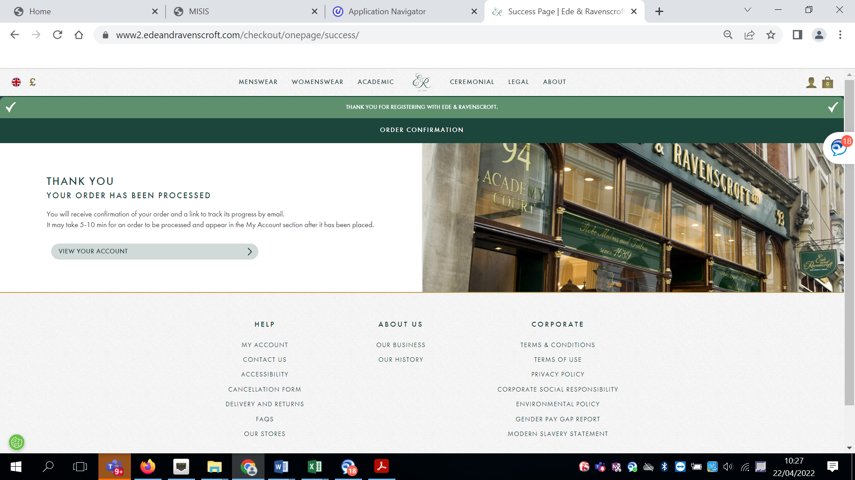

Once you have placed your order you should see the confirmation screen. An email will also be sent to you with details of your order.

